# Workgroup Configuration

For OFFICE-PC1

Step 1: Search and open System

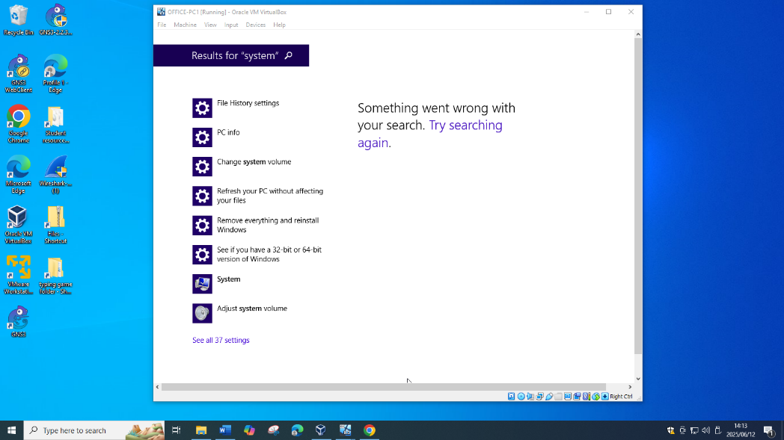

Step 2: Click Change Settings

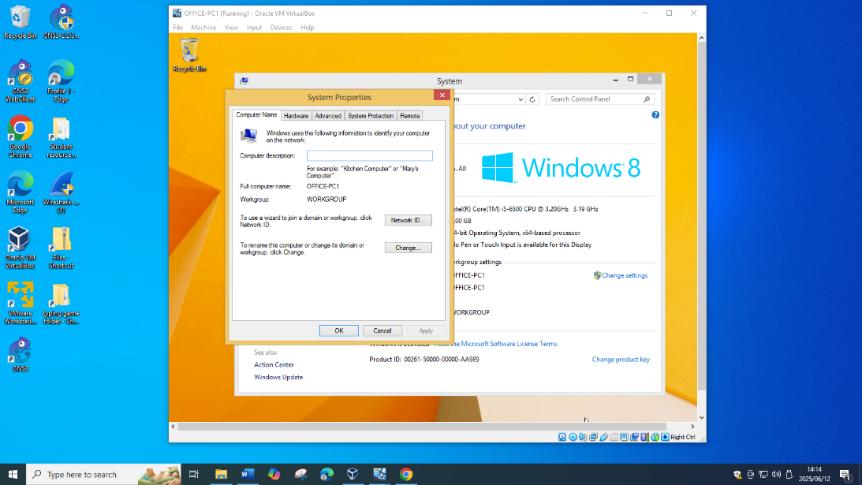

Step 3: Click Change

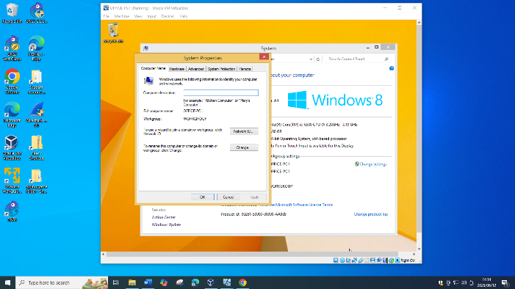

Step 4: Select Workgroup and name REMOTE-2025, Click OK, Restart

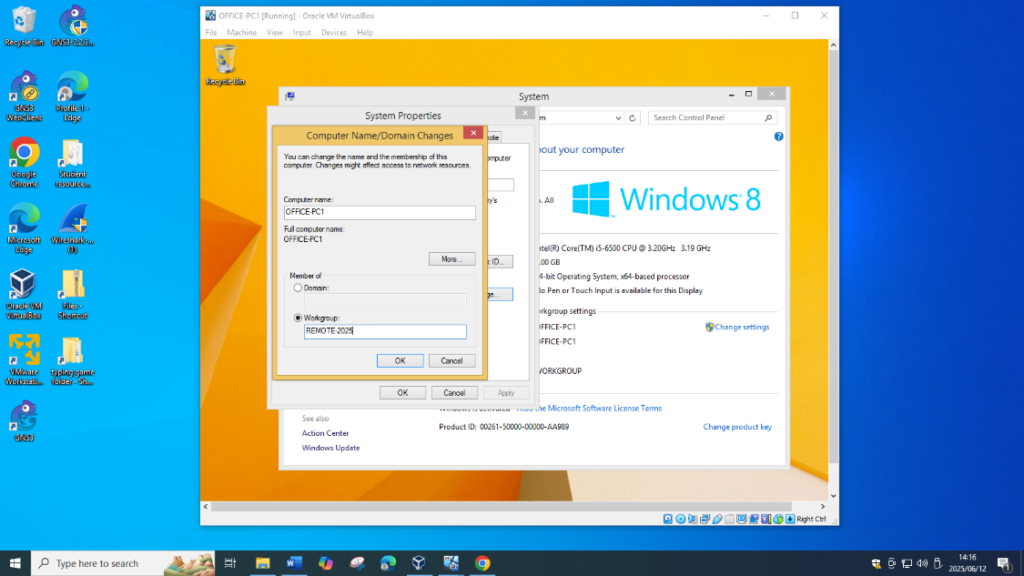

For OFFICE-PC2

Step 1: Open Control Panel

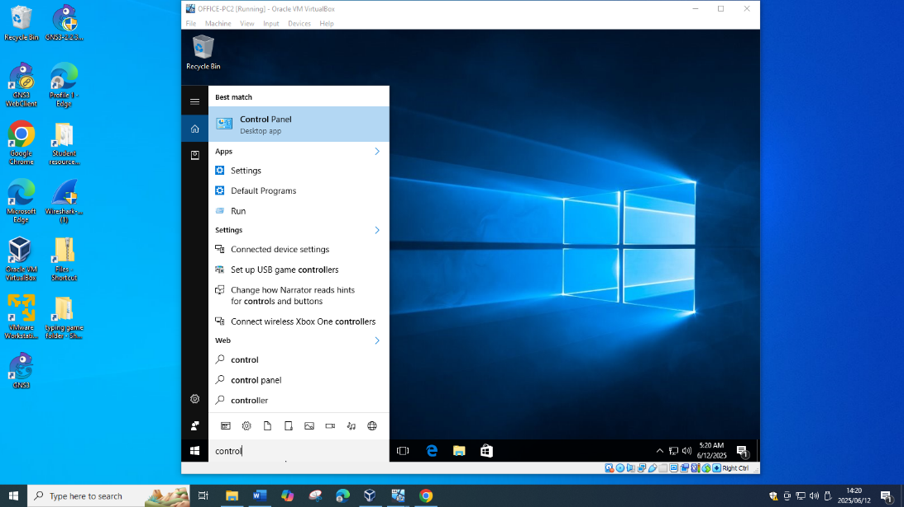

Step 2: Click System and Security

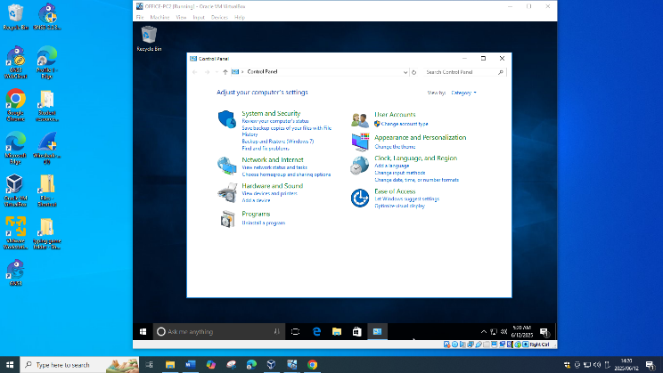

Step 3: Click Change Settings

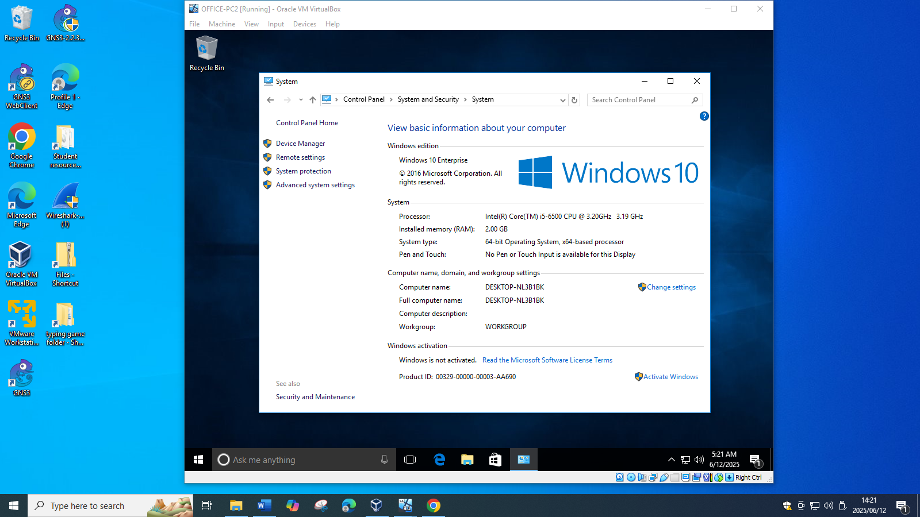

Step 4: Click Change

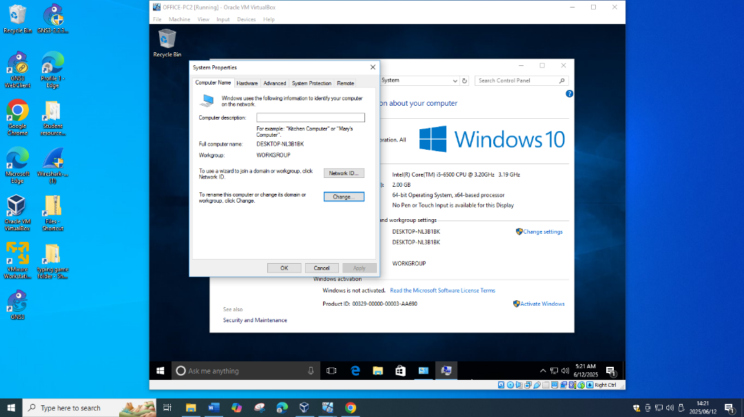

Step 5: Select Workgroup and name REMOTE-2025

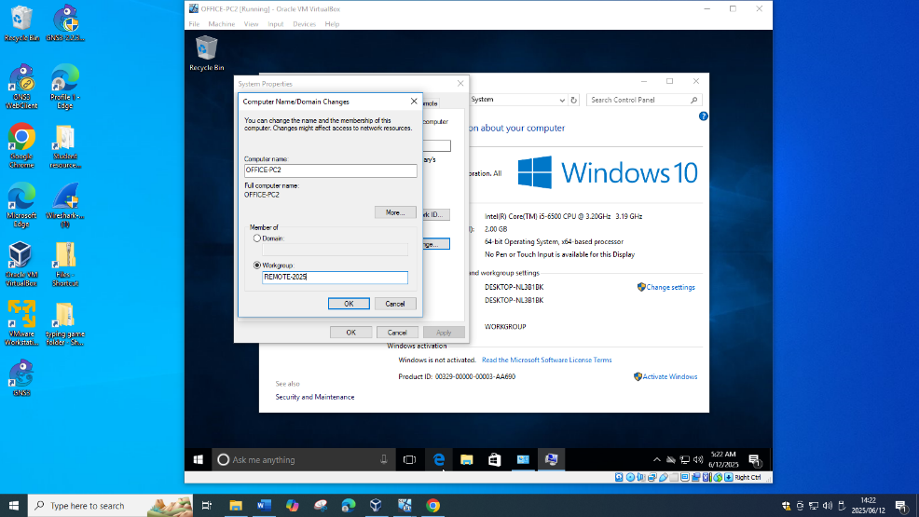

Step 6: Click OK

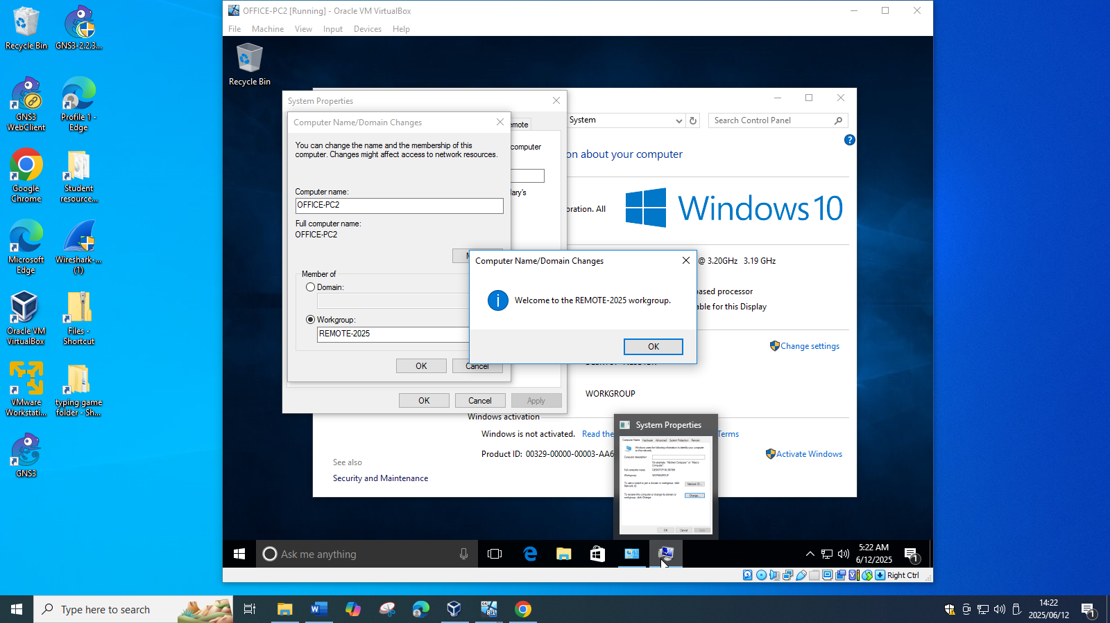

Step 7: Click OK

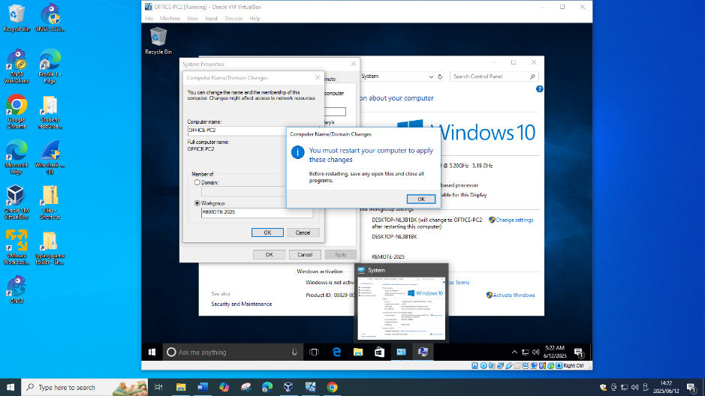

Step 8: Click Restart Now

